HAMSTICK DIPOLES
Using Hamsticks as a horizontal dipole is common on the bands but deployed vertically as a dipole not so much. A vertical dipole antenna is simply a dipole antenna that is mounted vertically instead of horizontally. Because of the orientation, it will have some characteristics different than a horizontally mounted dipole making the free-space performance of a vertical dipole the same as for a horizontal dipole.
It seems apparent that mounting the dipole vertically reduces the sensitivity to the ground conditions, but the ground still has a profound effect on the performance. I prefer verticals over horizontal dipoles because of the omni-directional exposure I get and throw in a bit of gain to boot. Less supports are required and by using Hamsticks in the vertical plane I don’t need ground radials. I keep the bottom whip of my 75m Hamsticks about one foot off the ground to achieve the lower angle of radiation most hams strive for. How did it work for me you ask? Read on.
Set Up and Testing
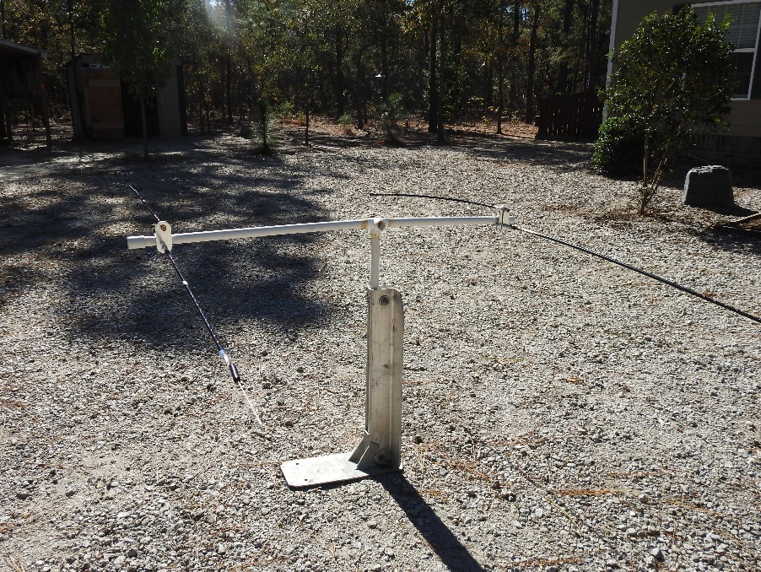
I’m not a dipole fan but I wanted to see if the design I came up with employing two pairs of MFJ Hamsticks (40 and 75m) on one 1” PVC support would work. So far so good so now I’ll try them in the vertical plane.
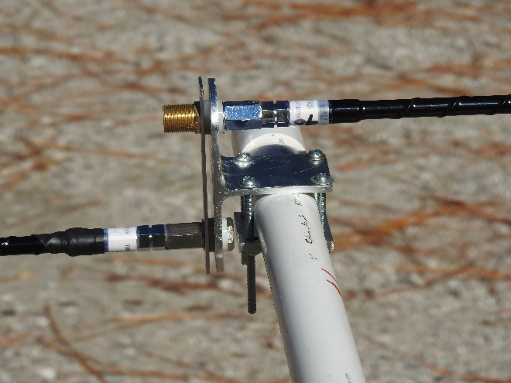

Horizontal Dipoles
KL7JR “One Person Antenna raiser”.

Vertical Dipoles
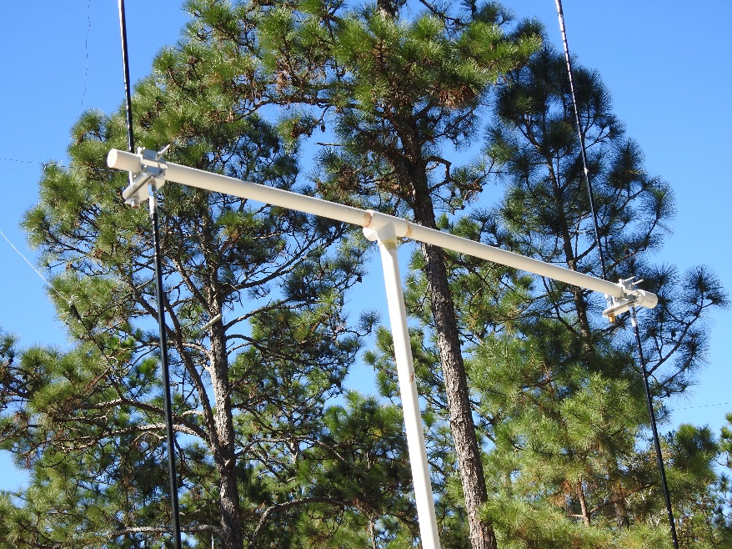
The first step is to resonate each aerial as a stand alone vertical then mount as a horizontal or vertical dipole. Your choice. I’m going with my original design for the vertical orientation for reasons stated above. Now when I need to adjust the stingers I use the same measurement for each pair as a starting point.
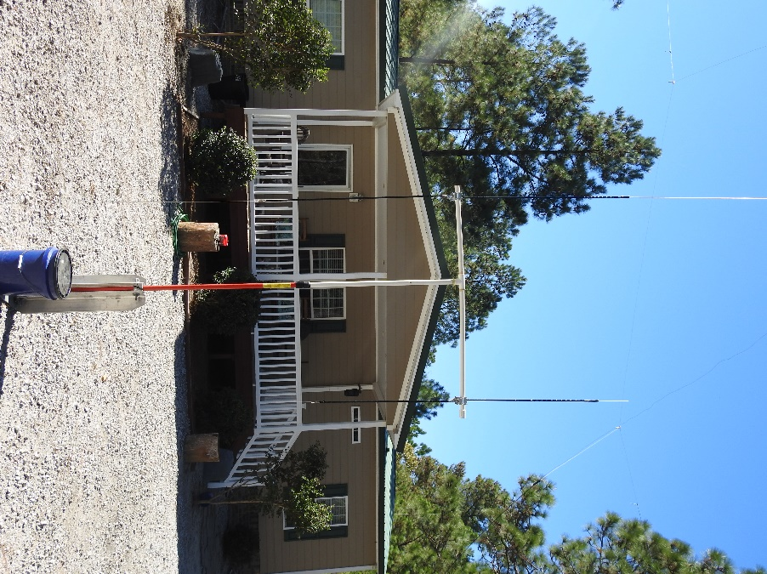

Vertical Dipoles On PVC Frame
(I need to cut the long bolts off!)
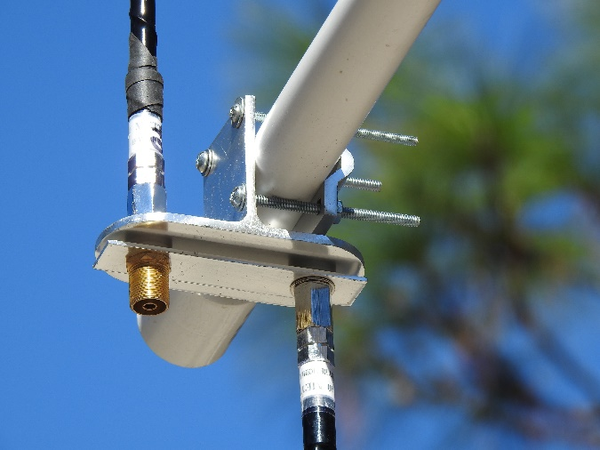

Resonating the Aerials
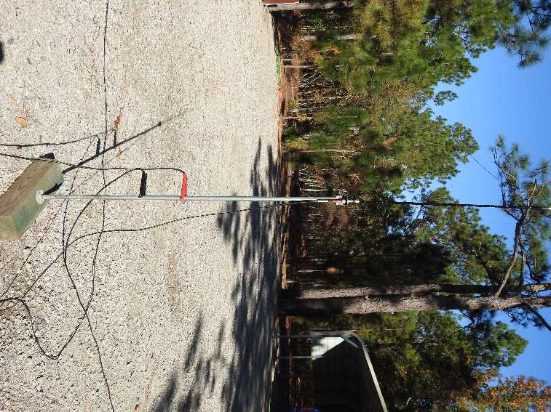
The 40m aerials were easy to tune as stand-alone verticals. After 3 “ups and downs” I had the SWR down to 1.2:1 on 7.230 MHz (midway between CCN net frequencies of 7.198 and 7.268). Resonating the 75m aerials was another story, one of several times adjusting the whip tips only to see an SWR of 2.1:1 on 3.900 MHz as the best I could achieve. I suspect I didn’t have a large enough ground plane for that low of a frequency. A pair of jumper cables (red and black) grounded the metal mast to ground.

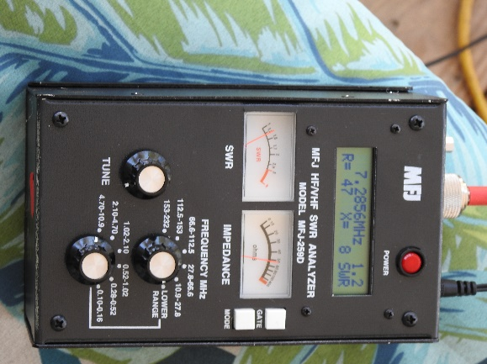
Next, I mounted the aerials as vertical dipoles and took readings again using my MFJ 259D analyzer. Much to my surprise 75m was much easier to resonate. The SWR was 1.3:1 on 7.230 MHz This was good enough for me. Forty meters was a bear cat to tune. I was down to moving the tips in or out at ¼” a time. On 7.230 MHz the best SWR I could achieve was 1.7:1. R and X numbers were good as in all readings I took. Using the aerials in this configuration proved the bandwidth was very narrow. That’s where tuners come to play as background conditions will vary from location to location.

Vertical Dipoles From Sesquicentennial State Park in Columbia, SC
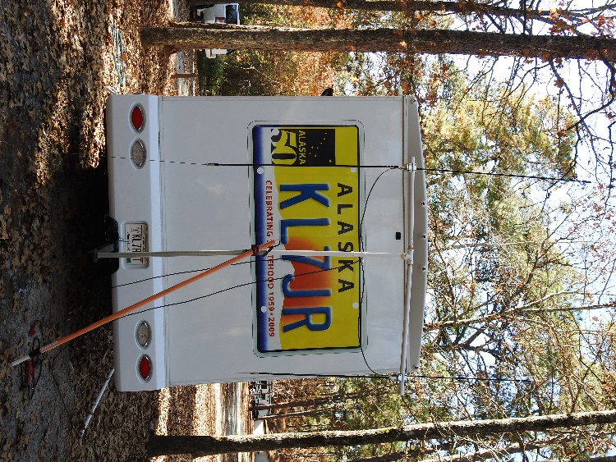
Before we head for the Florida National Parks I wanted to test the performance of the vertical dipoles. I managed to work AA0ZP, W0MYZ, KB8UEY/p OH, AG5T, AC2MT and a few others on 75m with respectable signals. The PVC mast left a lot to be desired so back to the drawing board for that. As stand-alone verticals mounted about 15 feet high I worked many other CCNers on 40 and 20m. My old EFHW modified for 160m netted me KB8UEY/p OH, W9WWG, K4JEL, K7HU, KR9G, KB1XP, KF4YI, KN4LEL, AC2MT and a few others on the 160m Late Net. My noise floor was only S3!
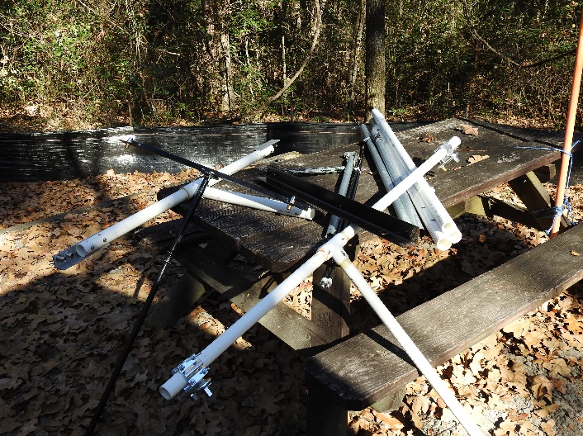
Picnic tables often become my personal work bench. I had antenna masts for several different antennas to assist in my experimenting.

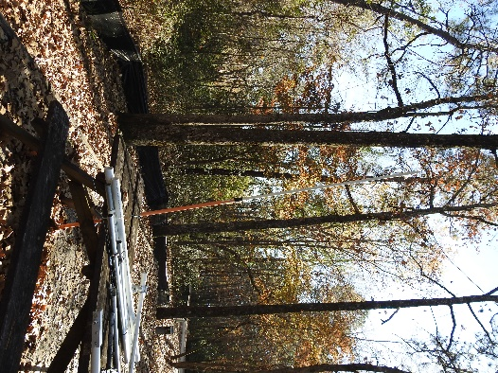
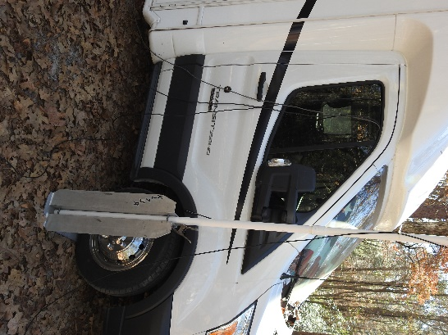
OPAR comes in handy for larger and heavier antennas I use. Painters pole (right) lashed to picnic table holds up my EFHW aerial as it ascends up about 40 feet to an old oak tree.

In Conclusion
You can homebrew your own dipole mounts or buy the commercially made MFJ-347 connector. For other antenna mounts see ANTENNA MOUNTS here.
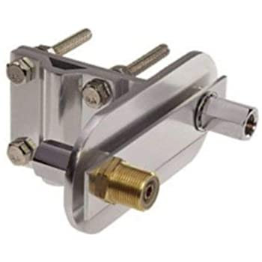
Homebrew Dipole Connector
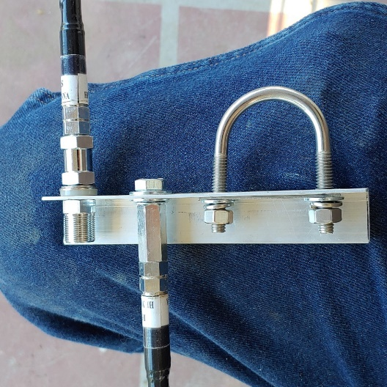

MFJ 347 Dipole Connector complete with connectors

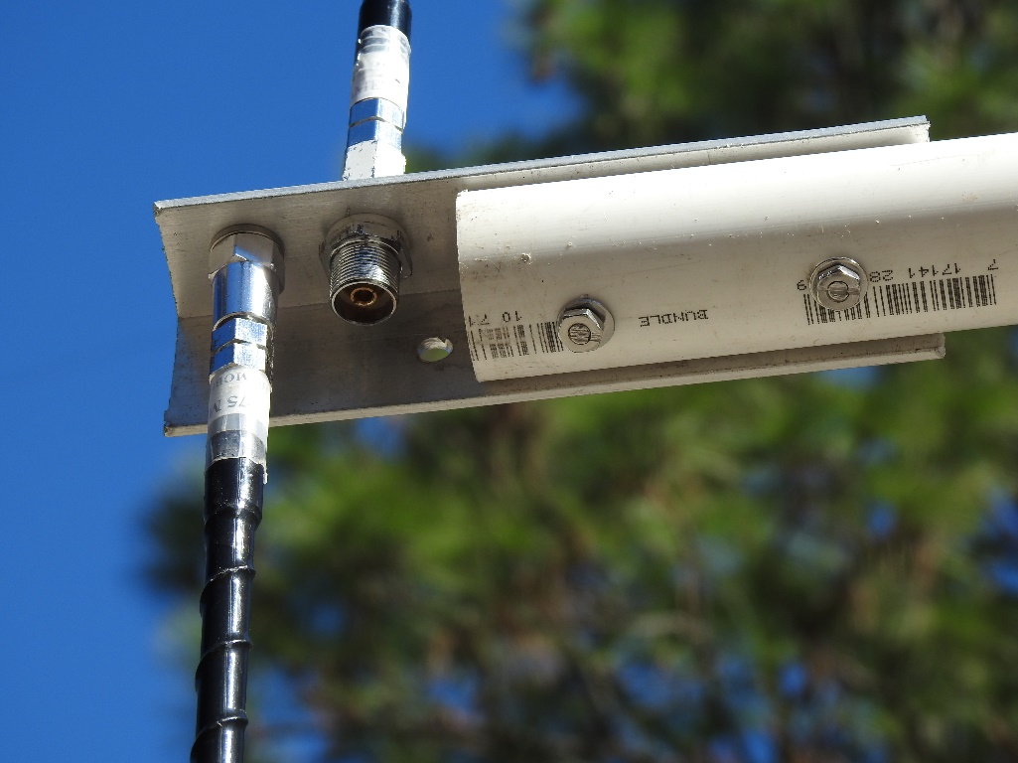

Homebrew vertical dipole mount using 1 -1/4” PVC pipe bolted to an 8” long piece of 1-1/2” aluminum angle.

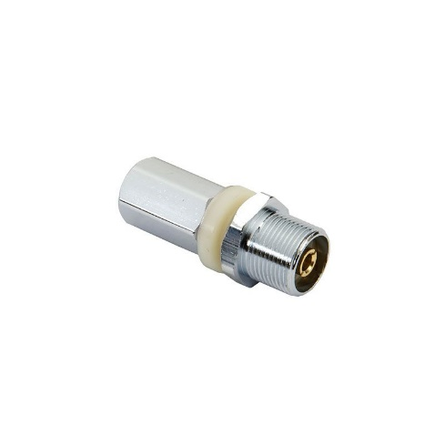
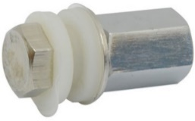
Ground radial connector (left- eliminate insulators). Coax stud mount connector (right, brass or alum.). These antenna connectors are available at most ham or CB dealers. Some truck stops also stock them.

73, de Yukon John KL7JR

Reference:
A Stealthy Homebrew Vertical Dipole Antenna Using Mobile CB Antennas (wolfington.net)
Ham Stick Vertical Dipole Antenna - Bing video
Simple and Inexpensive Dipole and V Antenna Mount by KL7JR (hamuniverse.com)

